

**LINK MONTHLY REPORT**

July 2022

1. **CONTENTS**
   1. Key Activities
   2. Latest Consumer Research – Cost of Living
   3. LINK Volumes and Value
   4. ATM Numbers
   5. Maintaining Access to Cash
   6. Footprint Report
2. **Key Activities**

LINK is the UK’s Cash Access and ATM Network and connects virtually all the UK’s ATMs and provides communities with access to cash through services such as cash at retailers’ tills and Banking Hubs. LINK continues to operate to its usual high standard and remains well positioned to support UK consumers’ access to cash needs through effective risk management and high levels of operational resilience. LINK is working closely with its infrastructure provider and Network Members, all of whom continue to perform well.

The LINK Board met in early July. Items discussed in detail included the Independent 2022 Board and Committee Effectiveness Review which was positive and came up with a number of useful suggestions which will be carried forward. The Board was pleased to hear about the constructive ongoing engagement with LINK’s regulators, including attendance at the PSR’s Annual Plan Event. The Board also gave detailed and careful consideration to LINK’s risk summary report (including the actions being undertaken to mitigate these risks), the latest finance report and detailed analysis of ATM transaction volumes against forecast.

LINK continues to put a lot of effort into people planning as recruitment and retention continue to be issues across the industry. There are no commercial or operational issues causing concern and LINK and its various service providers continue to perform to the expected very high standard.

1. **LATEST LINK CONSUMER RESEARCH – COST OF LIVING**

As the cost-of living crisis looms on the horizon, LINK has been doing research on how this may change consumers’ behaviour, specifically what people are planning to do to help cope with rising prices. Very few people expect to do nothing, and most have plans to reduce their spending.

While a lot of people are planning to reduce ***what*** they spend money on, eg restaurants, reducing electricity bills, using the car less, see below; relatively few at this stage seem to be planning to change ***how*** they pay for things as a way of cutting their spending, ie reducing contactless / using more cash. However, this is an area LINK will continue to monitor and it will be interesting to see how this changes as the impact of rising utility bills starts to bite in the autumn and winter.



LINK also asked the 9% who were planning to use cash more in response to rising prices why they did so, along with some other resulting behaviours. As might be expected, budgeting and controlling spending were most important factors. There were also some contradictory habits regarding ATMs, some saying they were using them more and taking out more on each visit, while others were reducing the amount of cash they were withdrawing to prevent overspending.



LINK is planning further research in the autumn and winter to see whether consumers’ behaviours change, and this will be published later in the year.

1. **LINK VOLUMES AND VALUES**

July’s 144 million transactions were 3.0% higher than last year’s and 3.7% above July 2020 when the UK was coming out the first lockdown and approaching the start **of *Eat-out-to-help-out*.** July was 7% higher than June and, ignoring 2020, this is the largest month-on-month increase for these months for many years. July’s 144 million transactions also make it the busiest month for ATMs since the start of the COVID-19 pandemic back in March 2020.



July saw almost £7.5 billion withdrawn from LINK ATMs, 3.3% up on last year and 7.1% up on June. Some of this was driven by higher average withdrawal values (see below) and it means the value of cash withdrawn from LINK ATMs is now around 25% less than before the pandemic in July 2019. As with volumes, it also means July’s values were the highest since March 2020, although only very slightly higher than those at Christmas, which always busy.



Weekly ATM volumes are currently tracking very close to the previous two years’, usually just below 2020 and just above 2021, a pattern which seems likely to continue over the rest of the summer, especially if the current good weather continues.

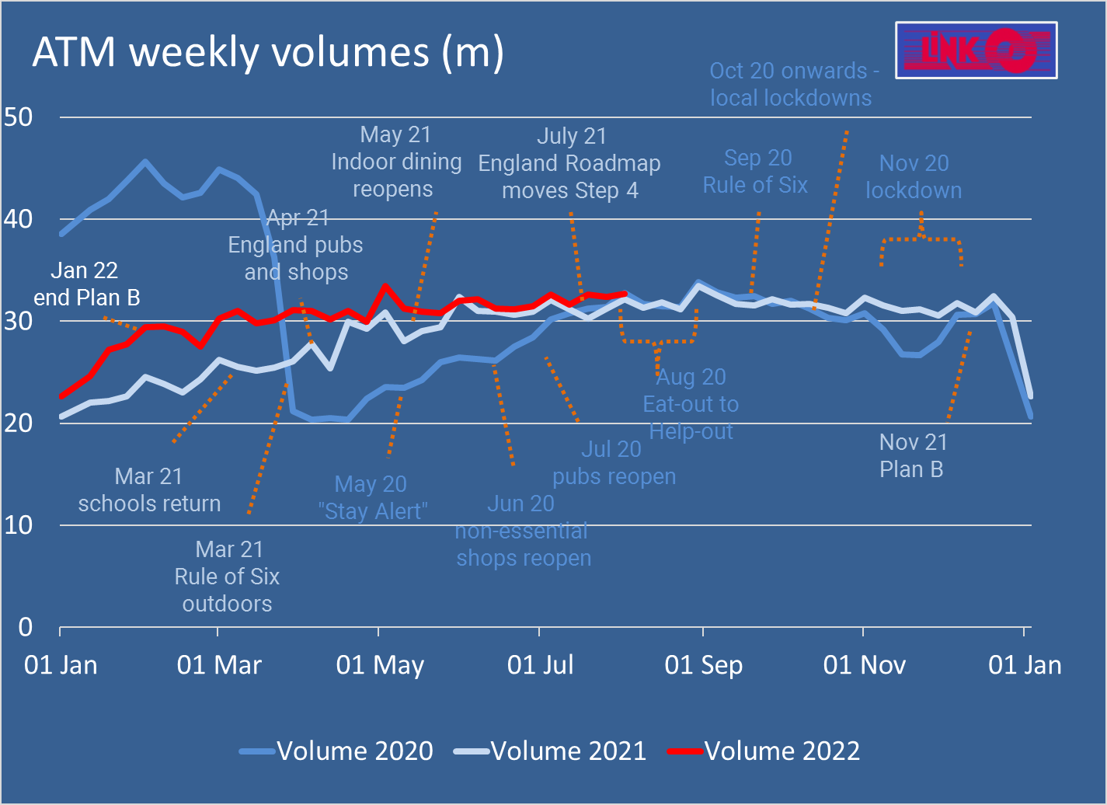

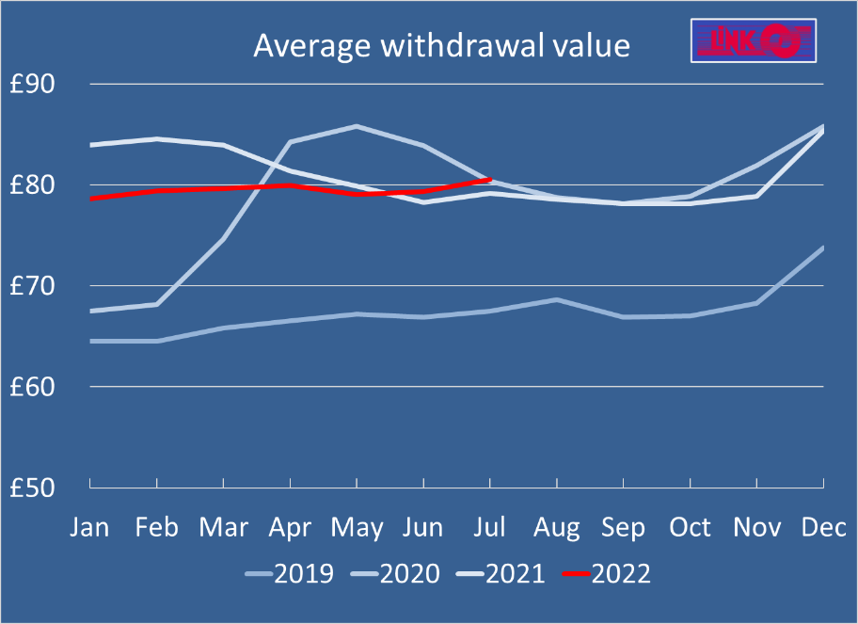

The average ATM withdrawal increased to £80.54 last month, the highest it has been this year and higher than the last two summers as well.

This could be a reaction to inflation increasing the price of goods and services which are paid for in cash. Pre-pandemic average cash withdrawal values were around £68, with a boost in December as people took out more cash for Christmas, so this higher average value is a distinct change in consumers’ habits.

1. **ATM** **NUMBERS**

ATM coverage across the UK in 2022 continues to be broadly stable and in line with LINK’s strategy and Financial Inclusion Programme objectives. The number of free-to-use remote, non-branch ATMs remains very consistent and, while there was a fall in ATM numbers in the early days of the pandemic, this has barely changed in the past year (see chart below).

This meant that the average remote free-to-use ATM did 2,742 cash withdrawals in July, compared to 2,664 in July last year and 2,592 in July 2020; however, this is significantly less than the pre-pandemic 3,660 cash withdrawals per ATM in July 2019. Each pay-to-use ATM, by contrast did just 421 cash withdrawals last month.

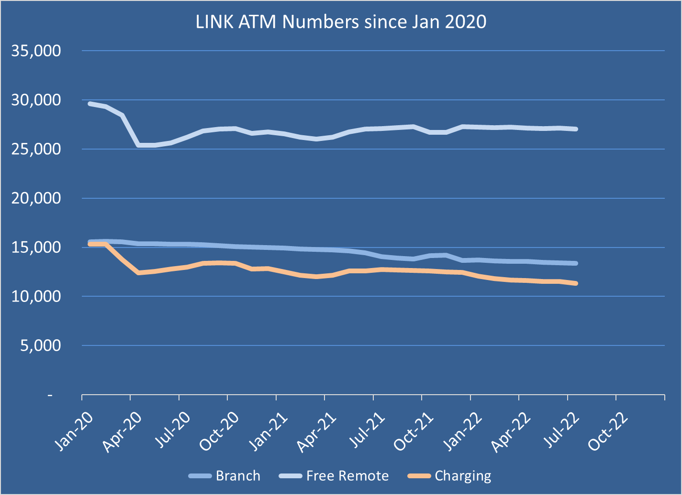

A breakdown of transactions across the different types of ATM, plus cash at the till, is below. As can be seen, branch ATMs now only account for 14% of LINK transactions although it should be remembered that branch ATMs will do a significant number of on-us transactions, where cardholders use their own bank’s ATMs and these are not processed by LINK. Pay-to-use cash withdrawals only account for around 3% of LINK transactions.

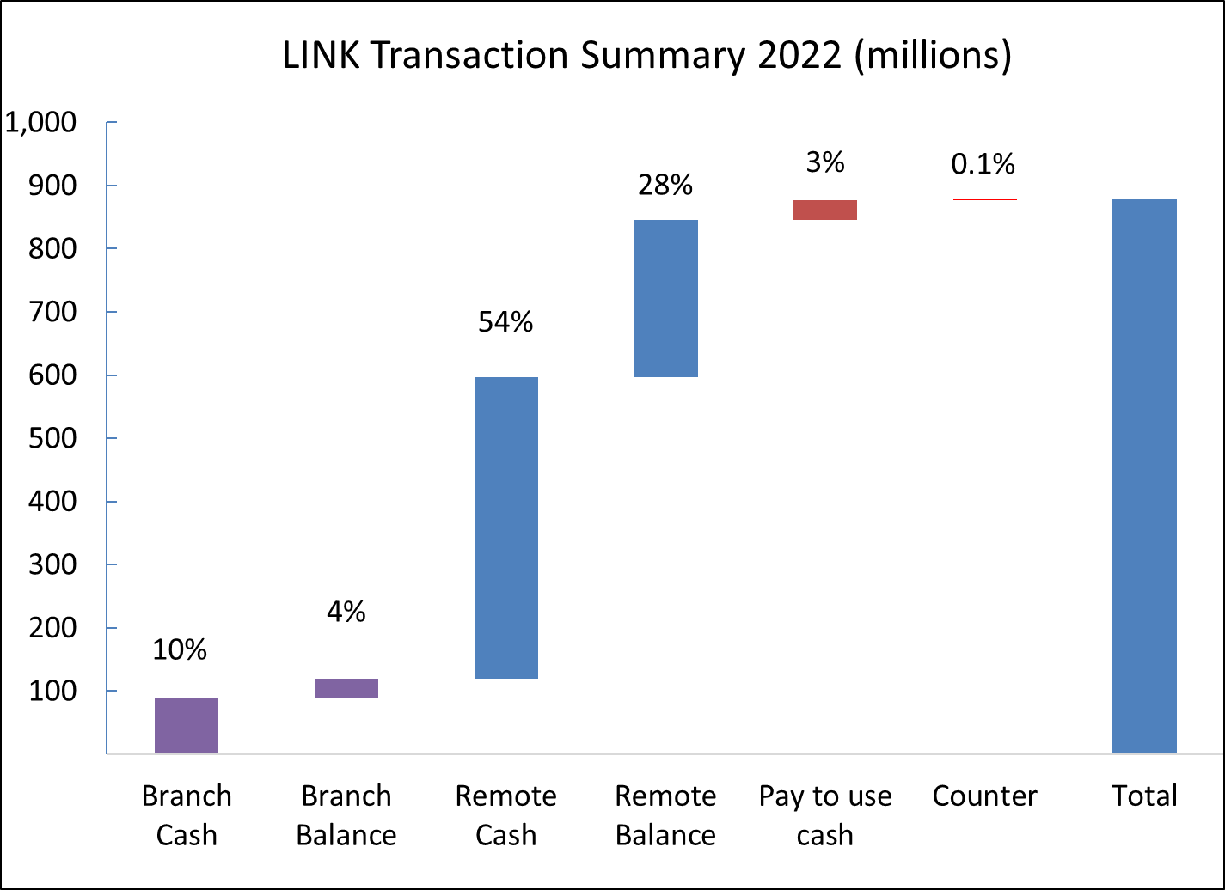

1. **MAINTAINING ACCESS TO CASH**

LINK’s Financial Inclusion Programme continues to be effective in maintaining free access to cash for consumers in rural, remote and deprived communities across the UK.

To-date, 92 lost free-to-use ATMs have been targeted for replacement and resolved, 40 through Direct Commissioning, 19 through Premiums and the remaining 33 by regular installation programmes.

Overall, over 3,500 ATMs get a subsidy as part of LINK’s work on financial inclusion. LINK is now using social media to further raise awareness of the initiative and continues to welcome requests for ATMs. Please see the LINK website for more details <https://www.link.co.uk/consumers/request-access-to-cash/>.

1. **LINK FOOTPRINT REPORT**

LINK is committed to maintaining free access to cash for many years to come through an extensive network of ATMs, which covers the same area as it did on 1st February 2018. This includes Protected ATMs which are machines 1km or more away from another free ATM and are therefore considered vital by LINK for their local community. These Protected ATMs are analysed every month and the changes are summarised below.

|  |  |  |  |  |  |
| --- | --- | --- | --- | --- | --- |
| **May 2022** |  | | | | **Monthly change** |
| Total Protected ATMs | 3,278 |  |  |  | 12 |
| Live ATMs | 2,857 |  |  |  | 7 |
| **ATMs No Longer Transacting** | **421** |  |  |  | **5** |
| Temporarily out of action |  | 18 |  |  | -4 |
| Investigations with operator underway |  | 8 |  |  | 1 |
| **ATMs Confirmed as Closed** |  | **395** |  |  | **8** |
| ATMs not being replaced (a) |  |  | 337 |  | 7 |
| **ATMs Targeted for Replacement** |  |  | **58** |  | **1** |
| LINK directly commissioning a replacement |  |  |  | 17 | 1 |
| **Resolution not Possible (b)** |  |  |  | **41** | **-** |
| **ATMs previously targeted for replacement and now resolved (c)** | | | | **92** | **4** |

Notes - LINK Footprint Report

(a) ATMs are not replaced where consumers have free access to cash over the counter from a nearby post office, where the site was not accessible to the public, where there are security concerns, or where there is assessed to be no community detriment following a site visit by LINK.

(b) Where it is not currently possible to replace a Protected ATM for reasons such as no suitable premises within 1km, no willing site owners to host an ATM or no operator willing to deploy an ATM. LINK may still consider alternative actions and these sites remain on file.

(c) Sites which were targeted for replacement through the Programme and now have free access to cash via an ATM, whether through Premiums, Direct Commissioning or through the free competitive market.